3. Scenario
You have been contracted by a small business called
You have been contracted by a small business called TechBridge Solutions to design their cloud network infrastructure. The business requires a virtual network that separates public-facing resources from internal back-end systems. Your design must account for at least two distinct network segments.

You are free to determine the specifics of the design — address ranges, number of subnets, and security rules — but your choices must be documented and justified.

4. Tasks and Mark Allocation
1 and 2
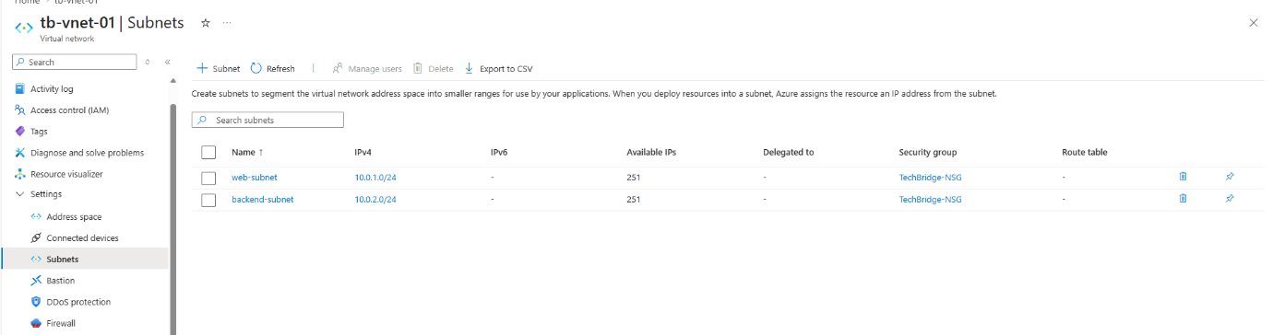
The first subnet is a public subnet and the second subnet is a private subnet. Both help with decreasing traffic.

Task 3
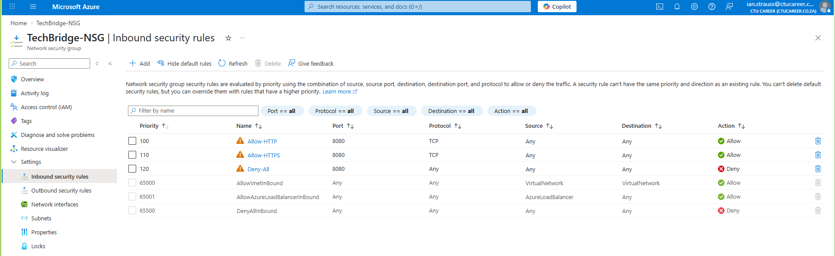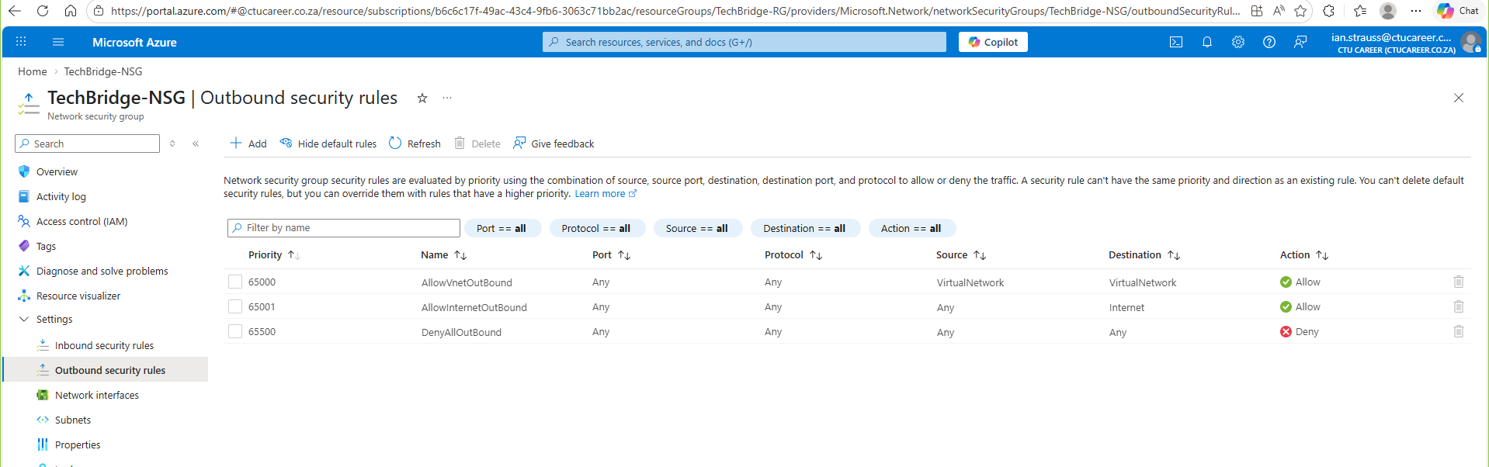

The Network Security Group (NSG) configuration for TechBridge consists of three rules: two inbound and one outbound. While simple in design, these rules provide a foundational level of network security.
The inbound rules are configured to control traffic entering the 10.0.0.0 network range. Specifically, HTTP traffic is denied due to its lack of encryption, reducing the risk of unsecured data transmission. In contrast, HTTPS traffic is permitted, as it provides a secure, encrypted communication channel.
The outbound rule focuses on protecting sensitive company data by blocking SQL traffic from moving between the internal subnet and the external subnet. This restriction helps prevent potential data exposure and strengthens overall network security.

